Exercises Php

**Evaluated skills :**

*→ Php functions*

*→ Arrays*

Fill in the blank :

Question 1 :

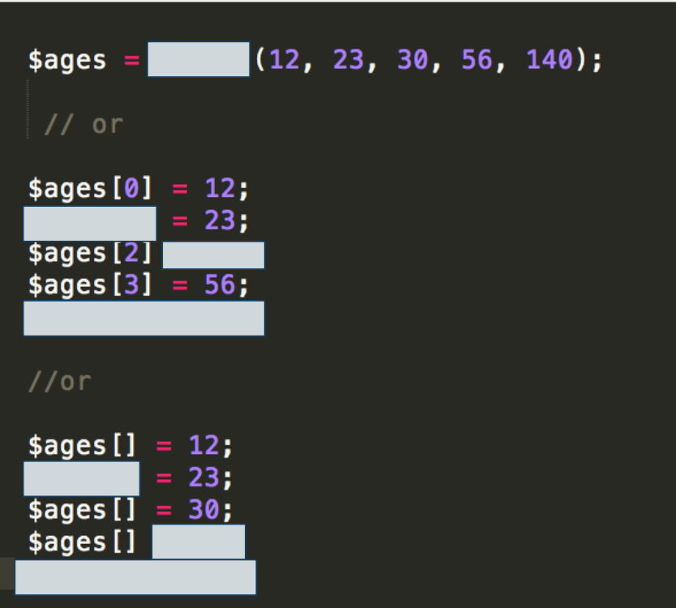

Question 2 :

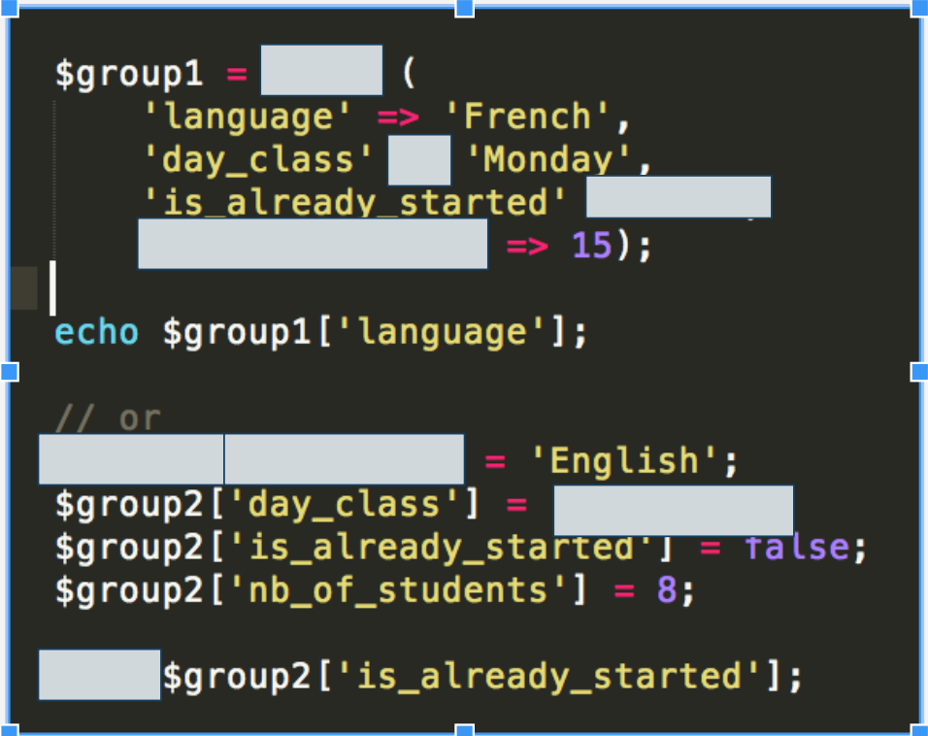

Question 3 : Write a for loop to display every elements in this array with the instruction echo:

|  |  |  |  |  |  |  |  |  |  |
| --- | --- | --- | --- | --- | --- | --- | --- | --- | --- |
| 0 | 1 | 2 | 3 | 4 | 5 | 6 | 7 | 8 | 9 |
| blue | red | pink | green | white | orange | black | purple | yellow | grey |

Question 4 : Write a foreach loop to display every elements in this array with the instruction echo :

|  |  |  |  |  |  |  |  |  |  |
| --- | --- | --- | --- | --- | --- | --- | --- | --- | --- |
| 0 | 1 | 2 | 3 | 4 | 5 | 6 | 7 | 8 | 9 |
| blue | red | pink | green | white | orange | black | purple | yellow | grey |

Question 5 : Write a foreach loop to display every elements in this array with the instruction echo :

|  |  |  |  |  |  |  |  |  |  |  |
| --- | --- | --- | --- | --- | --- | --- | --- | --- | --- | --- |
| x | 1 | 4 | 6 | 12 | 15 | 2 | 3 | 7 | 8 | 2 |
| y | 4 | 8 | 56 | 23 | 8 | 4 | 9 | 12 | 34 | 0 |
| z | 6 | 0 | 12 | 3 | 67 | 2 | 8 | 32 | 1 | 5 |

Question 6 : Test of pre-embedded function :

→ array_key_exists

in the first array of color :

test if 2 or 12 indices exists

in the second array of coordinates:

text if “x” or “k” exists

→ in_array

in the first array of color test if this values exists :

“white”

“maroon”

in the second array of coordinates test the existence of :

“x : 4”

(“z=12“ and x = 6)

“y=25”

→ array_search

in the first array of color test if this values exists :

“white”

“maroon”

in the second array of coordinates test the existence of :

“x : 4”

(“z=12“ and x = 6)

“y=25”